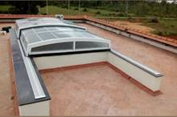 | 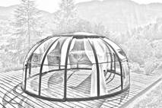 | 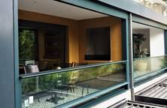
Automatic retractable roof - Add more splendour by allowing partial sunlight and night sky views. | Dome enclosure - Unique design for outdoor open-air-living. | Automatic vertical sliding window - Better utilization of space, and even a better air ventilation scheme.
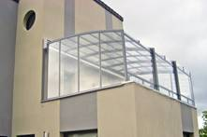 | 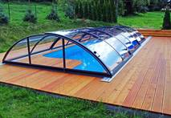 | 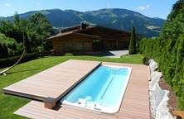
Balcony enclosure –  Enhances the idea of open air sitting with panoramic view. | Swimming pool enclosure –  Protecting pool to | Swimming pool deck-  Automatic cover that doubles up the functioning the deck.
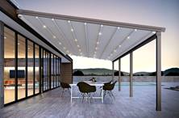 | 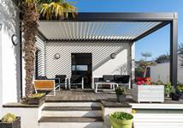 | 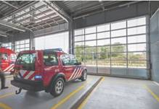
Retractable fabric roof (Pergola) – To create and outdoor luxurious, weather protected space. | Rotating louvers- Provides right amount of light and shed and protection from sun, rain and dew. | Garage sectional door – Good control over interior environment to create and maintain optimum air conditioning.
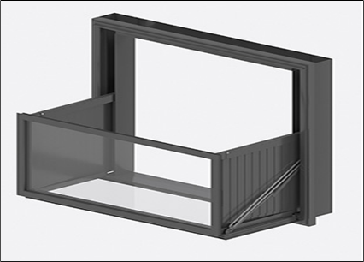 | 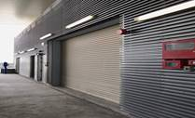 | 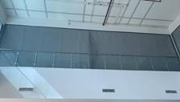
Foldable window balcony- An innovative product from NIHVA that converts the window into balcony | Fire rated rolling shutter – Close automatically on fire detection, and prevent the spread of fire and smoke. | Fire curtain - The best equipment for compartmentalizing the building, isolating the hazardous and high-risk areas.

Pls find attached our Products along company introduction letter and client list for your reference. We are Confident to be a part of your Prestigious organization/Projects and look forward to hearing from you. For further any query please feel free to contact us.
We are also pleased to inform you that we undertake an AMC and Maintenance contract for all of our products & for any of your existing facilities.
Let’s work TOGETHER…

